**Time Trigger Pipeline**

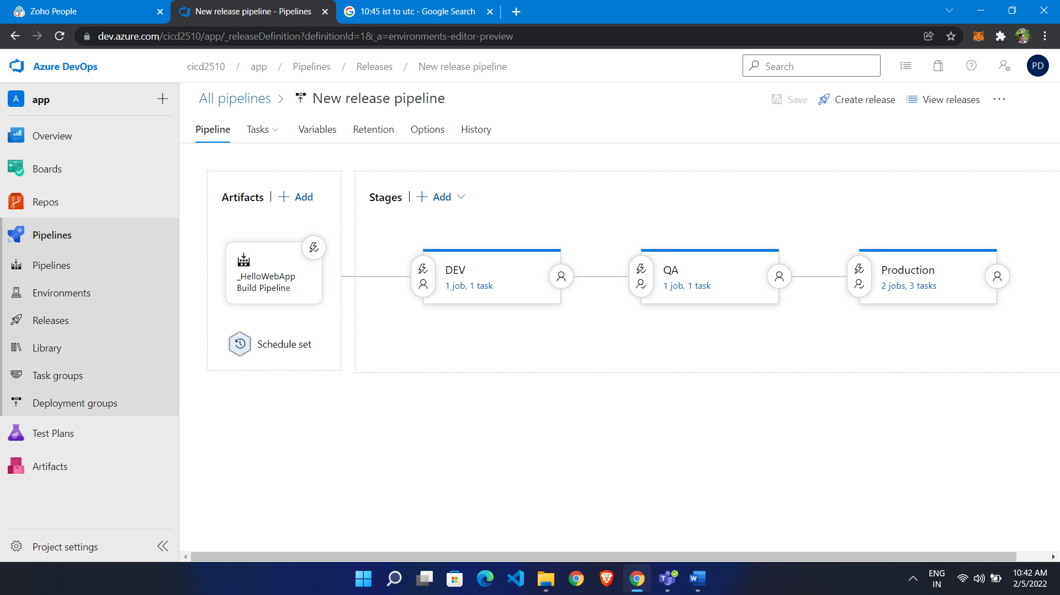

We scheduled artifact to 10:45 am (IST)

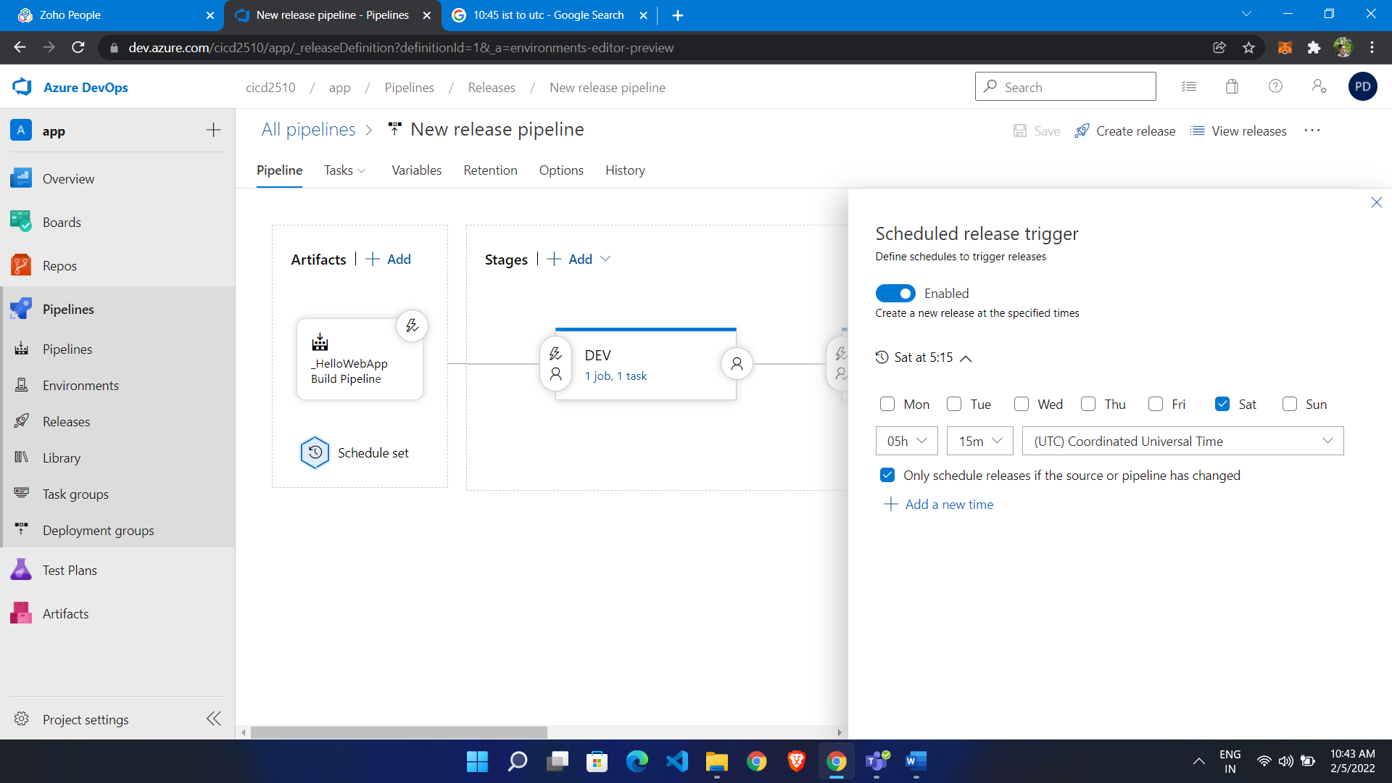

It will run automatically if there is not change but it is run

[https://docs.microsoft.com/en-us/azure/devops/pipelines/process/scheduled-triggers?view=azure-devops&tabs=classic#running-even-when-there-are-no-code-changes](https://docs.microsoft.com/en-us/azure/devops/pipelines/process/scheduled-triggers?view=azure-devops&tabs=classic%23running-even-when-there-are-no-code-changes)

Here we have schedualed 12:16IST to Dev and 12:14 to QA

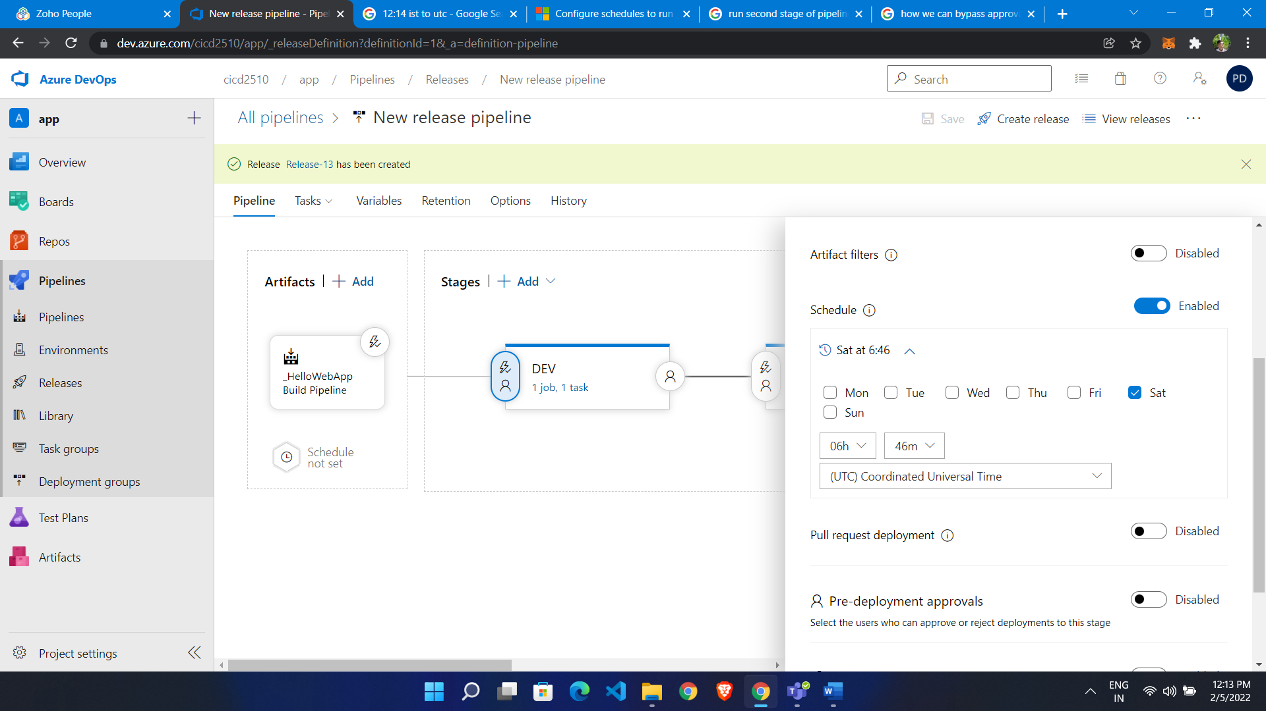

QA

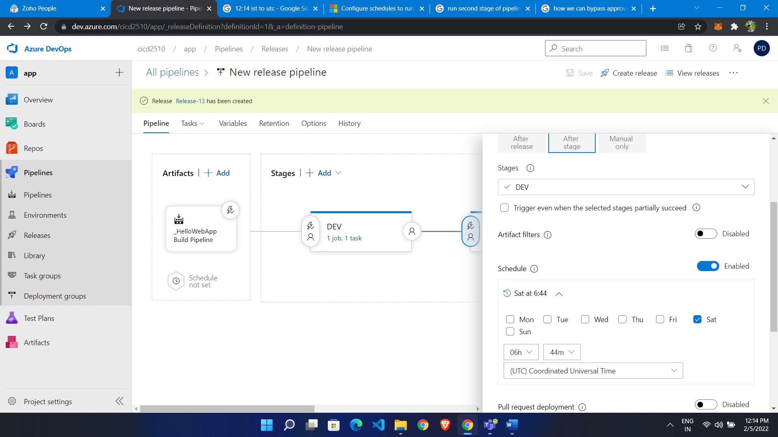

After release QA was not run first at 12:16 DEV Run first

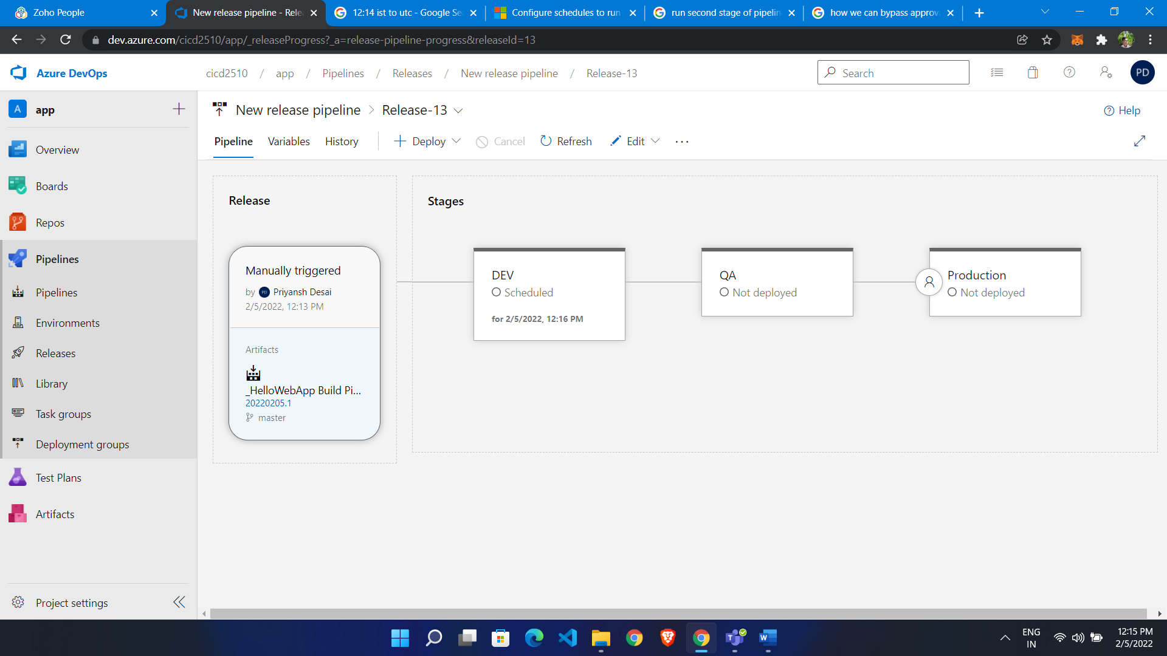

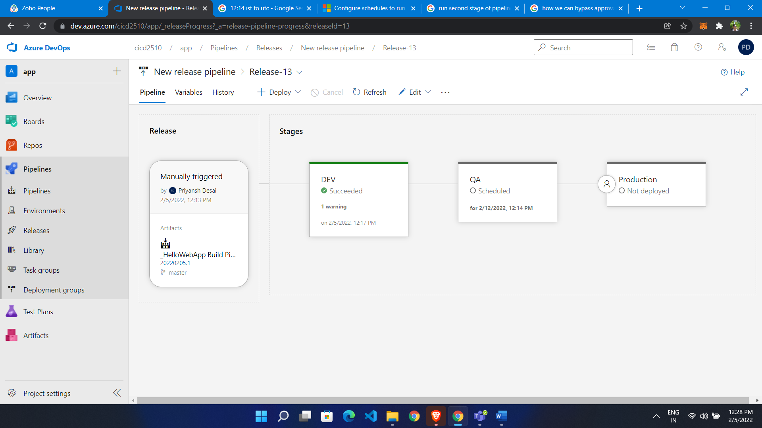

Here Dev Stage success QA not